**Household Hazardous Waste**

**Makayla McKibben**

**DSC500 T301**

**Theory 1:** Household hazardous waste disposal days drive awareness for hazardous chemicals/toxins/wastes and potential exposure.

1. In what month do most household hazardous waste days occur?
2. Why do "hazardous waste landfills," "lead poisoning," "mercury exposure," and "pesticide exposure" searches peak in April cyclically?
3. Why is there an offset between the cyclical "hazardous waste disposal" peak searches and the likewise cyclical peak searches for "hazardous waste landfills," "lead poisoning," "mercury exposure," and "pesticide exposure"?
4. Do searches for potential hazardous waste exposure symptoms peak with household hazardous waste days?
5. What are the most common symptoms of exposure to lead, mercury, and pesticides?

In order to understand the link between household hazardous waste disposal days and public awareness of hazardous waste and potential exposure, we may look at the search frequencies of each in Google Trends. More specifically, looking for what month or time of year most searches occur could give us insight into the correlation between these parameters. We may also look to see if there is a link between public awareness about hazardous waste exposure and people searching for symptoms. Hazardous waste includes a great many things, so we will limit our search to some of the most toxic and common hazardous waste constituents. Everyday household items that are hazardous waste include lead paint, pesticides, and mercury thermometers.

We will consider public awareness about household hazardous waste and hazardous waste first. Figure 1 shows the number of searches for "household hazardous waste disposal" and for "hazardous waste" from January 2008 to the present. As seen in Figure 1, there is a direct overlap in peak search times for both phrases. This overlap has the potential to indicate that there is a link between the two searches. However, this potential link necessitates more investigation. Moving forward, we may look for specific months when household hazardous waste disposal days are most popular in each state.

Figure 1

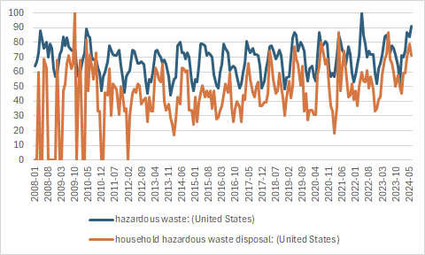

*“Hazardous waste” and “Household hazardous waste disposal” Frequencies*

The next item to consider is whether or not there is a connection between peak search times of household hazardous waste disposal and hazardous waste exposure. In order to theorize about this, we will look at household hazardous waste disposal days and see if each hazardous waste constituent we have chosen aligns with peak searches. Figure 2 shows the searches for "household hazardous waste disposal" and "lead exposure." Figure 3 shows the searches for "household hazardous waste disposal" and "mercury exposure," and Figure 4 shows the searches for "household hazardous waste disposal" and "pesticide exposure." For future research, we should look up common symptoms for each type of exposure and find their search frequencies.

Figure 2

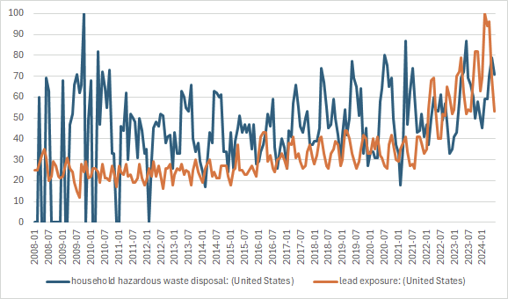*“Household hazardous waste disposal” and ”lead exposure” searches*

Figure 3

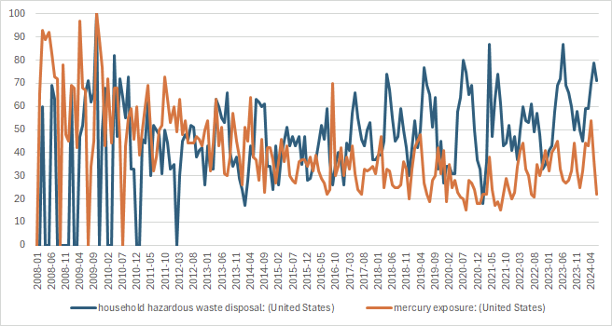*“Household hazardous waste disposal” and ”mercury exposure” searches*

Figure 4

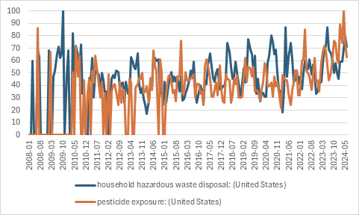

*“Household hazardous waste disposal” and “pesticide exposure” searches*

Each of these searches can show us a limited window of popularity with the public. We can see when most searches happen and whether or not the frequency with which they occur matches up. These searches can provide insight into whether there is a potential link between each search item or if they are unrelated searches. Further research into when household hazardous waste disposal days occur in each state is necessary. Additional research is also needed into the unique symptoms or combination of symptoms and their search frequency about household hazardous waste disposal days.

References

Google. (n.d.). Google trends. <https://trends.google.com/trends/>